**SQL QUERIES**

**Task 1** Display the names of the unique launch sites in the space mission

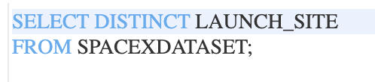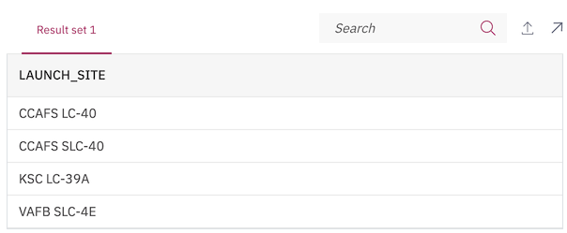

### Task 2 Display 5 records where launch sites begin with the string 'CCA'

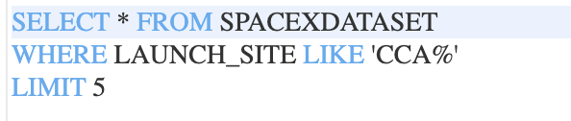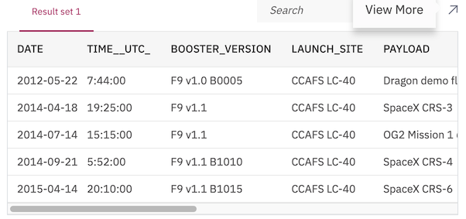

### Task 3 Display the total payload mass carried by boosters launched by NASA (CRS)

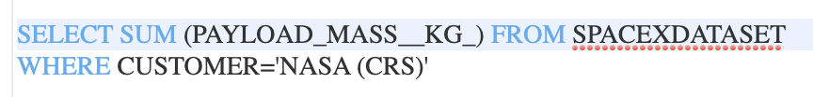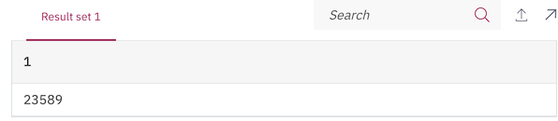

### Task 4 Display average payload mass carried by booster version F9 v1.1

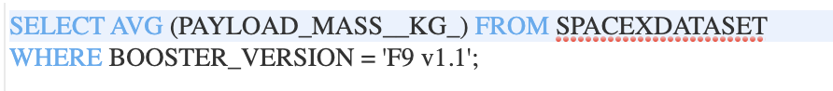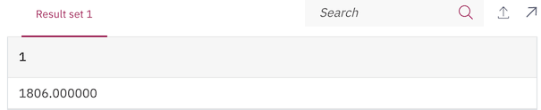

### Task 5 List the date when the first successful landing outcome in ground pad was achieved. Hint: Use min function

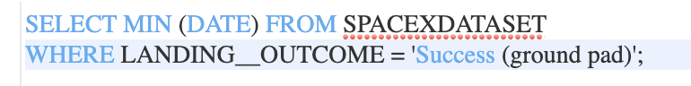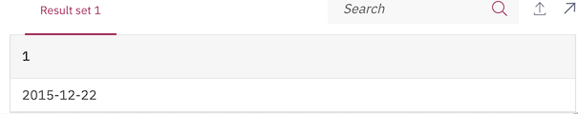

### Task 6 List the names of the boosters which have success in drone ship and have payload mass greater than 4000 but less than 6000../../../../../var/folders/jc/0n4266253fxbrzdtp6r8sswr0000gn/T/TemporaryItems/NSIRD_screencaptureui_uptead/Screen%20Shot%202021-10-03

### ../../../../../var/folders/jc/0n4266253fxbrzdtp6r8sswr0000gn/T/TemporaryItems/NSIRD_screencaptureui_B4jAWx/Screen%20Shot%202021-10-03

**Task 7** List the total number of successful and failure mission outcomes

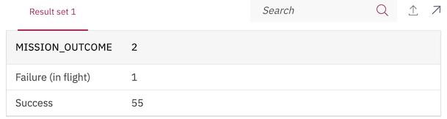

### Task 8 List the names of the booster\_versions which have carried the maximum payload mass. Use a subquery



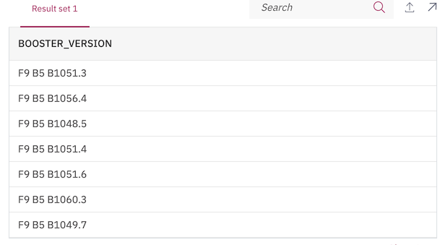

**Task 9** List the failed landing\_outcomes in drone ship, their booster versions, and launch site names for in year 2015



### Task 10 Rank the count of landing outcomes (such as Failure (drone ship) or Success (ground pad)) between the date 2010-06-04 and 2017-03-20, in descending order

